**Collections Overview**  
* Back in Section 9 we looked at 3 of Java’s List types.  
* That was the List interface, the ArrayList, and also the LinkedList classes.  
* Those form part of the Java collections framework and that framework also includes things like sets, maps, trees, and queues.  
* So at the top level of the collections framework is the **Collections** class.  
* This class exposes static methods that either operate on collections such as the sort method or they also return collections objects such as the List method.  
* The interfaces in the collections framework allow the framework to be extended and they define methods for all the fundamental operations that are required for the various collection types.  
* One of the design goals of the collections framework was that there should be good interoperatibility amongst various collections, so not just the ones included in the framework, but literally anything that may also be created in the future that is a reasonable representation of a collection.  
* That also includes Arrays.  
* Arrays themselves couldn’t be made part of the collection framework without changing the Java language. However, the framework does include methods that enable collections to be moved into Arrays and vice versa. And additionally methods to allow Arrays to be viewed as collections.  
* The main components / the core elements of the Collectionsframework are:   
=> interfaces - these are the abstract types that represent collections, including the List interface  
=> aggregate operations  
=> implementations - this is the concrete implementations of the interface: ArrayList, LinkedList…  
=> algorithms - the Java JDK provides a range of polymorphic algorithms that work on collections objects - technically speaking objects that implement the collection interface and they provide reusable functionality.  
* First, let’s review the ArrayList and LinkedList objects as well as the List interface and consider them within the context of the Collections framework.  
* What I will do is use a simple seatbooking system in theater to see how these classes that we've used earlier fit into the Java Collections Framework. So theater seats will be numbered with a row letter, and then a seat number within each row. I'll keep it simple and not have different numbers of seats, and that type of thing.  
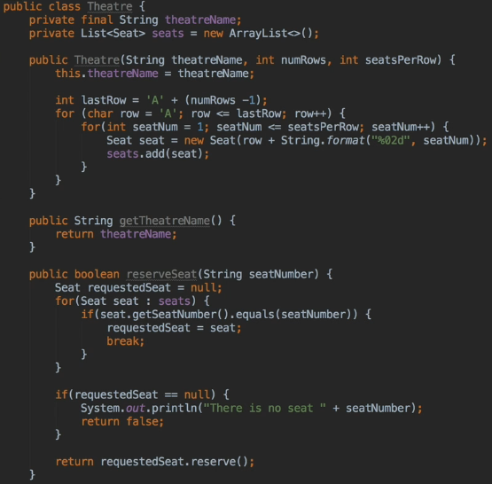  
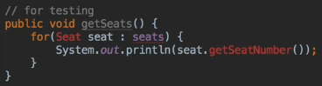  
* Let’s add a **private** class Seat. It’ll be an inner class of the Theater class.  
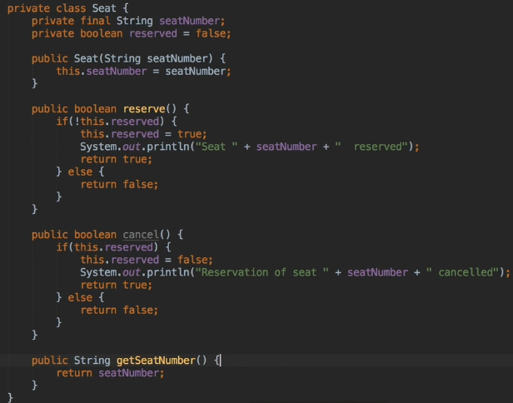

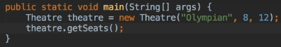  
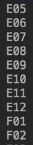  
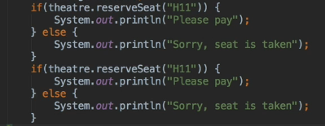  
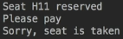  
* In the next video we’re going to look at changing our data structure which is defined in Theater.java on line 10 - the seats using an ArrayList, we’re gonna start changing that to a few different formats, a List and then also looking at turning it into a Collection for making it more generic and seeing how that all works.

**Binary Search**  
* We can easily change the format to a LinkedList and the code will still work.  
  
* **But we can be even more generic than that, we can change List to a Collection. The advantage of doing that is it enables us to use any of the Collection classes to hold our Seats**.  
<https://docs.oracle.com/javase/tutorial/collections/interfaces/index.html>  
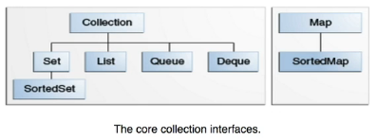  
* The framework contains a separate hierarchy for maps which I’ll be discussing later.  
* We can also use HashSet or LinkedHashSet that implements Set if we want to.  
  
  
* In HashSet the seats are in a different order but they’re still there.  
  
* In LinkedHashSet they’re in order again.  
* This should demonstrate how ArrayList and LinkedList fit into the Collections framework and that they can be replaced with other data structures if that structure provides benefit for a particular task.  
* With that said, however, you must remain on the same level of the hierarchy. So while we can use Set, List, Queue and Deque, we can’t drop down a level and still expect things to work.

* The Collection also includes a TreeSet and that implements SortedSet so sort of one level down.  
* TreeSeat implements SortedSet and actually what it does it’s NavigableSet which extends SortedSet and it’s got an additional requirement that elements in it must be comparable because that’s how the set is sorted.  
* As we move down the hierarchy, the interfaces become more specialized so we can only replace classes with other classes that implement one of the core collection interfaces at the same level.  
* Let’s talk about some of the remaining methods provided by the collections framework to work with lists.  
* The reserveSeat method that we have isn’t really efficient the way we’ve written it. You can more or less say it’s referred to as a **brute force search in that it scans every element until it finds the one we want**.  
* The collections class provides a **binary** **search** method that performs much better.  
* In order to get that to work, we need to implement the Comparable interface in ours Seat class so that Java knows how to compare two Seats.  
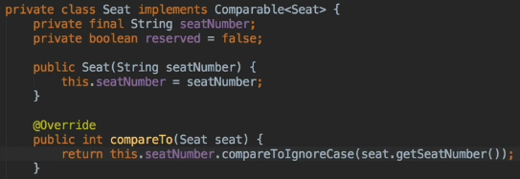  
* That’s gonna return the number < 0 if it’s less, 0 if it’s equal and > 0 if it’s greater than.  
* We’re really just using a **compareToIgnoreCase** method that’s built into the String class.  
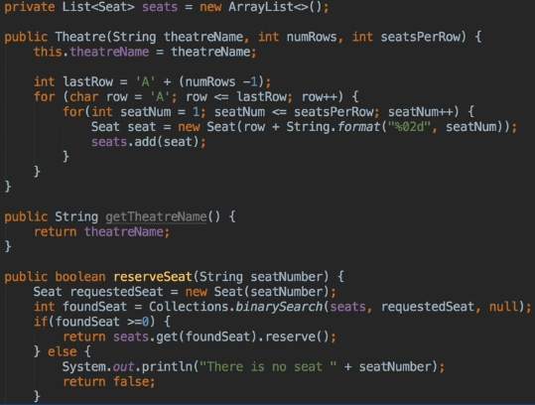

* I’m gonna paste in the code from the Java’s binary search method and adapt it to our code so that we can add an output to see how many times it’s called compared to our previous method.  
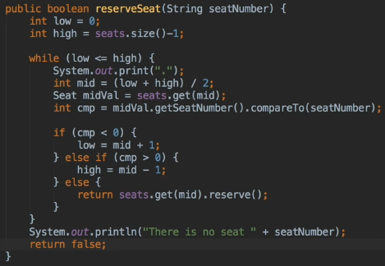  
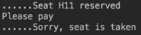  
* Significantly less than the brute force search.  


**Collections List Methods**  
* **We generate our seats sorted so there’s no need to sort them before performing the search**.  
* **But the Collection’s sort method is available if needed**.   
* And interestingly enough, it uses a very efficient **merge sort** and that performs much better than the bubble sort used in an earlier challenge.  
* We’re gonna have a look at the reverse method that the Collection class provides to sort a list in reverse order.  
* Now so that we don’t mess up the seats list for our Theater, we have to really look at a way to use the List’s ArrayList constructor to copy one List into another.  
* The Collections framework does provide a method to copy Lists and other Collections objects, but it doesn’t really work as you may expect. In fact, it’ll only copy a List into an existing one, of at least the same size.  
* We’re going to demonstrate the problem after the next few examples.  
* So that we can look at these methods easily in the main method, we’re gonna change the Theater class so that the seats field is public and the Seat class itself is also public.  
* This is only for our testing of these concepts.  
  


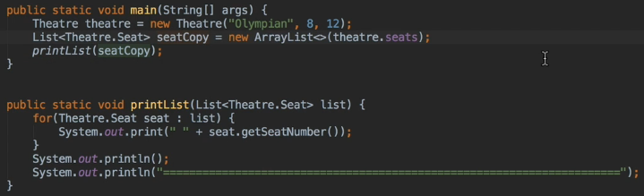  
* Now we can create a new arraz of Seat objects and if we pass in the existing seats from our Theater object, we’re going to get a new List containing all the seats.  
  
* The method that we use to create seatCopy and populate it with all the elements from Theater.seats is called a **Shallow Copy**. What that does is creates an ArrayList containing all the elements from the List that were passed to the constructor.   
* **It’s very important to note that these elements aren’t copied - hence the term shallow copy - if we modify one of the seats say by reserving it, then thata seat will be reserved whichever List we check for it. So you may have a new List but the contents are the same objects. They are effectivelly the same shared objects**.  
* So seatCopy.get(1).reserve() will make that seat reserved in theater as well because they’re sharing the same data.  
* Two separate lists, each containing references to the same 96 Seat objects.  
* **Collections.reverse()**  
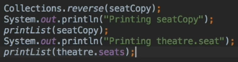  
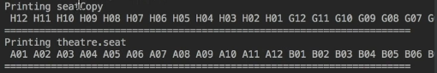* Clearly they are separate ArrayLists and the only thing is that they refer to the same objects.  
* There’s also a **Collections.shuffle()** method in the Collections class to shuffle the elements in sort of a pseudo-random order.  
* **Collections.min()** => returns the smallest element  
* **Collections.max()** => returns the highest element  
* It’s using the compareTo() method to determine that sort order. Basing the results on that natural order from the compareTo() method for a given list. And incidentally, **these work even if the List hasn’t been sorted**.  
* If you want to implement your own sort or for any other reason, the Collections class provides a **Collections.swap()** method to swap two elements in a List. We pass the name of the list and the index position of the two elements that we wanna swap.  
* Let’s create a variation on the bubble sort method from the Arrays challenge. But this time, we’re going to use nested for loops, and the reason for that is we had a student in the course ask if that was also acceptable.  
  
  
* **This could be useful in situations where speed wasn’t so important but memory was at a premium**.  
* **Merge sort requires far more memory than a bubble sort and this could be an issue with extremely large Lists**.  
* But even so it’d probably be very rare that you’d want to use your own sort routine rather than the ones that are built into the Collections framework.  
* Unlike the printList() method that had to access the getNumberSeat() getter and therefore only works on seat lists. But this sortList() we’ve made generic so it can sort any kind of List of Theater.seats so long as they implement the comparable interface.  
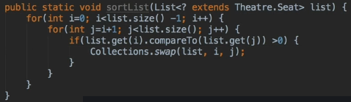  
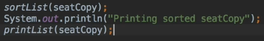  
* I’m gonna finish this video with a look at a rather odd copy method that’s provided by the Collections class.  
* It takes 2 parameters: the destination and the source list. The destination has to be of a generic type. There’s a superset of the source List and it basically means it can be a Colleciton, an Iterable, or a List and the source must be a List.  
* The problem that tends to arise with the **Collections.copy()** method is that people either expect to use it as we just did when we used the List constructor to create our copy of our seats, or what happens is the people may expect to create a deep copy of a List.  
* As opposed to a shallow copy, a **deep copy** is a copy where the elements are not just references to the same elements as in the original list, but are themselves copied.  
* Collections.copy() method is gonna find out if the destination is big enough to hold all the elements to be copied into it. That leads to a problem:  
  
* They think they allocated the amount of size for the ArrayList so they should be able to run that.  
  
* You actually get an error. The reason for that is that the allocation code only sets the capacity of the ArrayList, giving it the potential to hold that many elements but initially containing none. So it still doesn’t actually create a number of elements. So to get this to work you need to have 96 seat objects in that new list before we can attempt to copy.  
* With that said it’s really hard to think of an actual use for the Collections.copy() method although it would allow the elements of a List to be copied into another Collections object provided the object had been initialized by enough elements first and I guess that’s probably why it was included.  
* We’ve covered most of the Collections methods that can be used on Lists.

**Comparable and Comparator**  
* Let’s look at the Comparable and Comparator to understand how the sorted collections work.  
* Let’s change the seats to private and also use the binary search code from Collections (instead of the code we used for testing).  
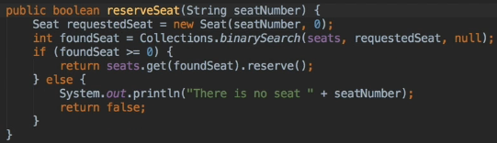  
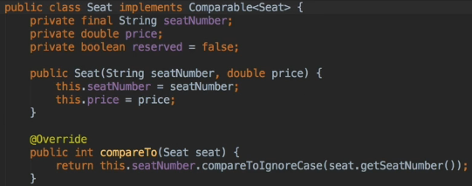  
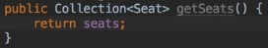  
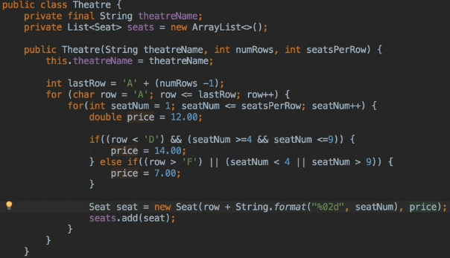

* Let’s now clean up the code and use the price.  
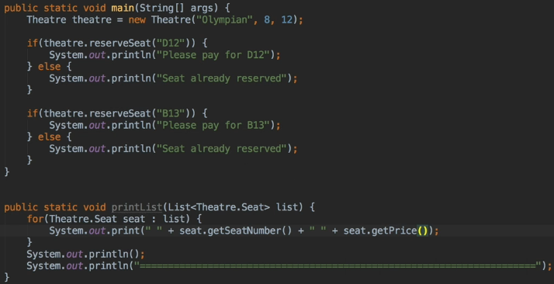  
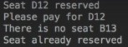  
* In terms of how it works because the Seat class itself implements Comparable, we have to override the compareTo() method and that’s often a very simple thing to do.  
* So a compareTo() method should return a number < 0 if the object should sort less than the object that is being compared to.  
* Now because this is exactly what the string .compareTo() method does and the string.compareToIgnoreCase methods as well because that’s just the same except it’s ignoring the case in letters of the alphabet - we can use that to implement our comparison.  
* If you were creating a compareTo() method for a class that’s got more than one key field such as people’s names for example and where you probably wanna sort first on surname then on first name when people share the same surname, you just perform a test of surnames and return a negative or positive number as appropriate. Then if the surnames are equal, instead of returning 0, you then test the first name and return negative / 0 / positive depending on how the first name’s compared.  
* So in other words as long as the compareTo() method works as we’ve described, the objects implementing it can be sorted, as we saw.  
  
  
* **There’s also another way to use the sort method - and that’s to pass it a Comparator**.  
* It’s similar to a Comparable.  
* The Comparator interface defines a single mthod called compare().  
* Unlike Comparable, the objects to be sorted don’t have to implement comparator. Instead, an object of type Comparator can be created with a compare() method that can sort the objects that we’re interested in. In this case it’s seats of course. And more than one Comparator can be created and it allows for objects to be sorted in different ways which is pretty cool.  
* So we can either create a Comparator object within an existing class, or we could create a new class that implements that Comparator interface.

* **Let’s have a go at the first way using an anonymous Inner Class within Theater**.  
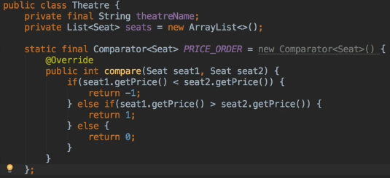  
* It may look like we’re instantiating the Comparator interface but remember from section 10 that it’s an anonymous inner class implementing Comparator and it’s providing an implementation of the single compare() method.  
* There’s a serious problem with this method - and if you intend to use a Comparator, please make sure you finish this lecture first because I’m gonna be discussing the problem soon because there is something major you need to be aware of.  
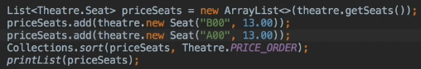  
* Right now our Comparator is based only on the price.  
* **We can add as many Comparators as we want**.  
* **The Comparator doesn’t have to be static but it makes it easy to use if we don’t need a class instance in order to use it**.  
* In our case we made the Comparator a static variable of the Theater class and that’s because the Theater class is controlling all access to the seats.  
* **But thinking about it, it could have made more sense to include it in the Seat class itself**. Especially if Seat was not an inner class. But had we done that, there would have been no Seat instance available in main to call on. So static would for that reason be a lot more convenient.  
* And just as a digression before we look at the problem with our Comparator’s compare() method, there’s an interesting suggestion IntelliJ makes about the Comparator. Clicking on its definition in the Theater class, IntelliJ will show you how to suggest a few interesting things:  
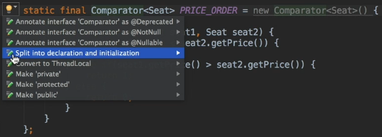  
* If we click this, we get:  
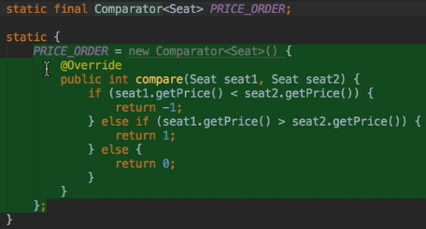  
* The declaration of PRICE_ORDER becomes a standard static final declaration but IntelliJ then inserts a static initialization block into the code that initialized the PRICE_ORDER Comparator.   
* Now we only recently discussed static initialization blocks so it’s quite good to see a practical use of it in this scenario.

**Maps**  
* Before we move to maps and hash maps, I did allude to a potential problem that could come up when you’re using the compareTo() method.  
* If you read the Java documentation on the Collections framework, you find that there’s a lot of talk about it and they used words like an **ordering being consistent with equals**, that’s sort of their phrase. It comes out to be quite simple.  
=> A method that produces ordering that is consistent with equals will only return 0 if the elements being compared actually are equal. Our compareTo() method behaves in this respect.  
  
* But looking at our Comparator’s compare() method though, this is definitely not consistent with equals:  
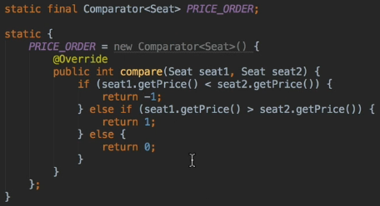  
* Comparing any of the seats with the same price will return 0 when they’re obviously not the same seat because of course we can have multiple seats with the same price, so this causes problems with SortedSets and Maps actually if they’re sorted using a Comparator such as ours then that’s inconsistent with equals. It’s quite easy to fix here, all you need to do is do further tests on the seat number whenever the price is equal.  
* I’m gonna keep it like this for now so that we can see the problems that can arise.  
* Now let’s have a look at the Map interface and some of the Java classes that implement it. The Map interface is part of the Collections framework even though it’s not a true Collection in a true sense of the word as we’ve talked about it previously.

* The Map interface replaces the now obsolete Dictionaries abstract class and like the class it replaces it, it **maps keys to values**. So a **language dictionary is a classic example of a map, with the keys being the words in the dictionaries and the values being the definitions of the words**.  
* Unfortunately the analogy falls a bit with the English language because many English words have the same meanings.   
* **Java Map can’t contain duplicate keys and each key can only map to a single value**.  
* Maps, like all the core Collection interfaces, are Generic. They take 2 types: one for th key and one for the value. It’s possible to use raw maps where the types aren’t specified but as we’ve seen in the lectures on Generics, this isn’t a good idea.  
* **Map<type, type>** **HashMap<>()**  
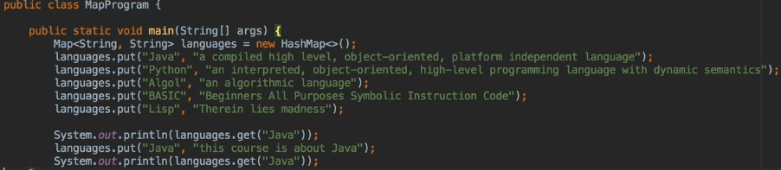  
* **.put()**  
* **.get()**  
* **One important feature of Maps is the keys are unique**.   
* **So if you try to use a value again, the old value gets overwritten, you don’t get an error**.  
* The put() method can be used to tell if a value is being added for the first time, it can be useful in certain circumstances to know that, it returns the previous value if there was one.  
  
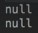  
  
  
* If you only want to add a key if it’s not already there, you can use the **.containsKey()** method to check to see whether it exists.  
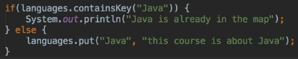  
* There’s also a **putIfAbsent()** method and that’s only gonna add to the Map if the key is not already present. But that’s really intended to prevent concurrency issues so that one thread does not add to the Map only for that entry to be overwritten by another thread, so it doesn’t help in the null case because it’ll happily overwrite keys with no values.  
* One way to print our Map’s contents is to loop through all the keys in the Map using the   
**.keySet()** method and it returns a set of all the keys. We’ll be covering Sets later so we’re just gonna loop through it now.  
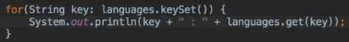  
* **There’s no specific order, there’s no guaranteed order with HashMap**.

**Map Continued and Adventure Game**  
* **.remove()**  
* **We can also remove a key if it’s mapped to a certain value**.  
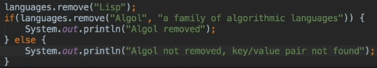  
* **The remove() method returns true/false**.  
* **.replace()** method is used to **replace the entry for the specified key if it’s already mapped to a value**.  
  
* The .replace() return null if it doesn’t find any value for the given key.  
  
* That would update it only if that particular value already existed.  
* One good use for this would be for example if you’re updating someone’s name after they got married, you can ensure that the correct person’s updated, that there’s no chance of it accidentally overriding the wrong info.  
* **Keys and Values can be any object**.  
* We can even use Map types as the values in another Map.  
* You could also add a Map as a value to itself although it’s probably not a good idea.  
* It’s important to point out that unlike other languages such as Python for example, there’s no requirement that the keys of a Map be immutable. Immutable objects are things like Strings and integers whose value can’t change. For example when we assign a new String value to a String variable, what we’re doing is we’re changing the value that the variable holds, we’re not changing the String. So “Algol” for example which we used for one of the keys earlier, can’t be changed. On the other hand, an ArrayList can change by having new items added, when a new value is assigned to existing entries.  
* With that said, the **Java docs does warn that great care must be exercised if immutable objects are used as Map keys**. The reason for the warning is that a Map object can behave unpredictably if the key objects change in such a way that equals comparisons are affected. But you probably have to do something fairly advanced for it to affect you. **Using classes as keys is in itself fairly advanced**.  
* One thing that’s not permitted is for a map to contain itself as a key.  
* Let’s create an adventure game based on the original Colossal Cave Adventure, which was one of the first adventure games that came out.  
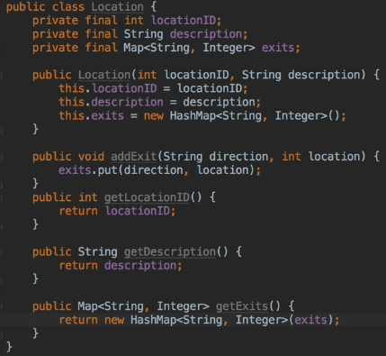  
* The reason we’re defining getExists this way is that instead of just returning the exists Map, I’m creating a new HashMap and passing our exists in the contructor so a new Map is created that has all the makings of the exists Map.   
* **The reason that this would be a useful technique is that nothing outside of that class can change exists, so the getter returns a copy of the exists so if the calling program wants to add or remove mappings from it then the exists mapping field won’t be affected. That’s really important**.  
* So although we won’t be using the Location class as a key in the Map, we use that later to show some **ways to make your classes immutable and returning mutable objects from a getter this way is one of the techniques to make sure that it works**.  
* The numbers are converted into Integer objects by autoboxing.  
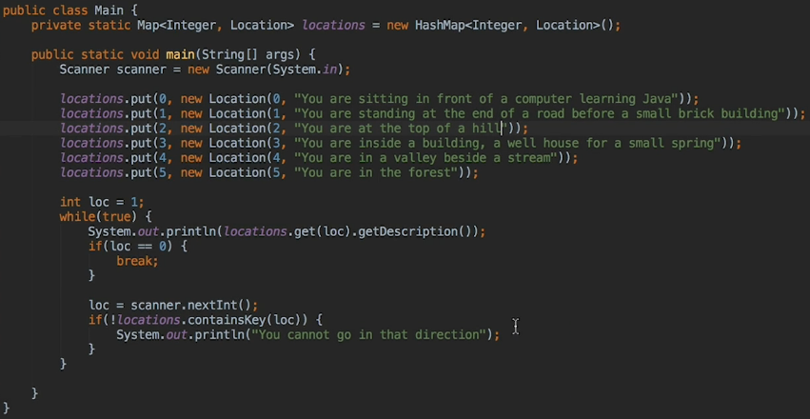

**Adding Exits to the Adventure Game**  
* locations => Map<Integer, String>  
* exits => Map<String, Integer>  
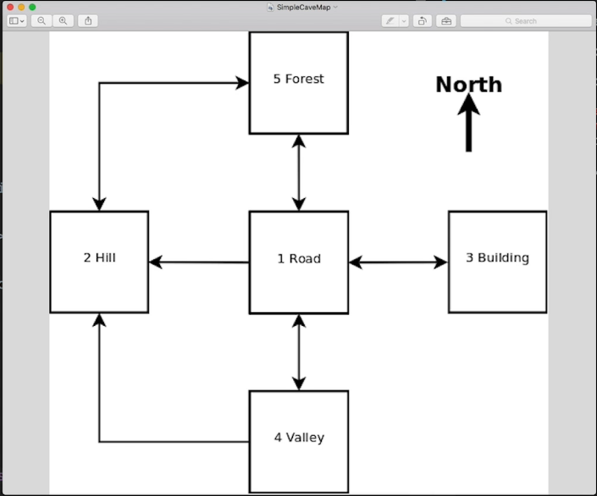s  
* Let’s now add the exits.  
* **Unfortunately Map Literals are still not available in Java. So we really have to use repeated calls to add exit for each Location.**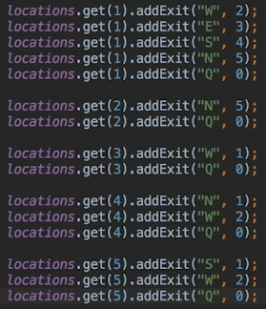  
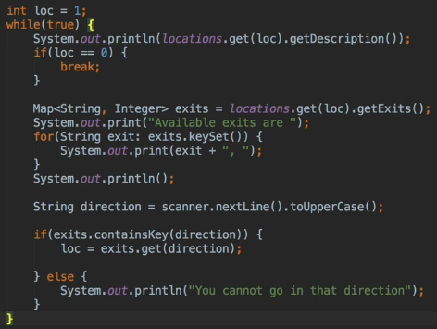  
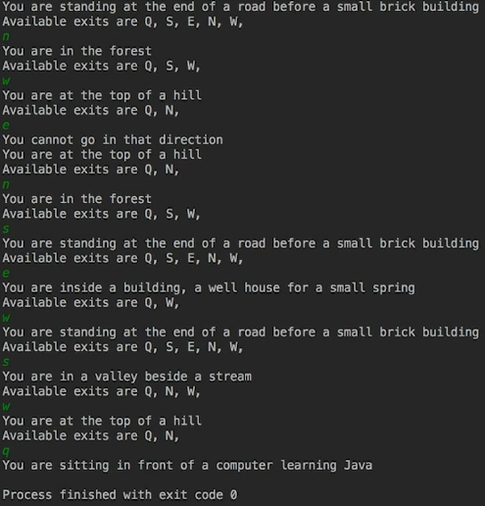  
* Since the Q appears in all the Locations, we can add it to the Location constructor.  
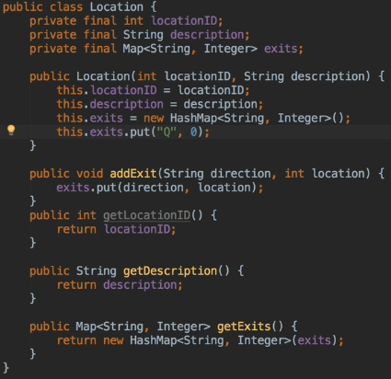  
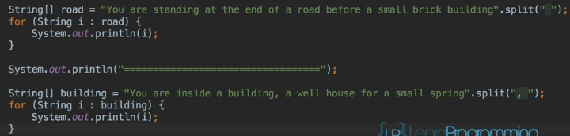  
* someString**.split()**

**Adventure Game Challenge**  
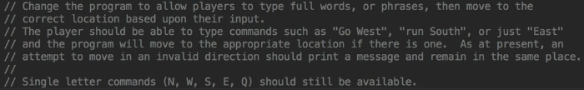  
* We’ll create a Map containing the words that will be recognized and the locations that will result and then add a bit of code to split the player’s input. They’ll each have to be ckecked to see if they are a key in the Map and if they are, the single letter value is returned, otherwise no action is taken.  
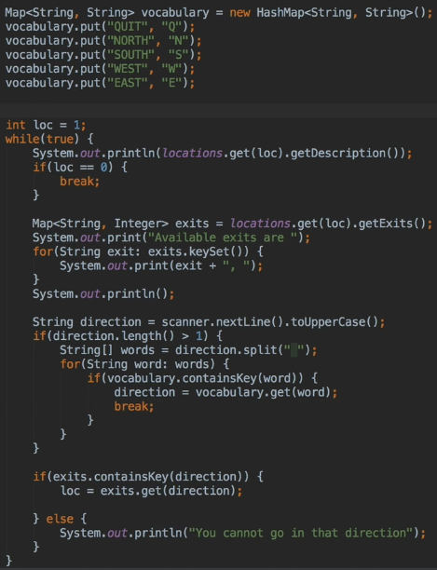  
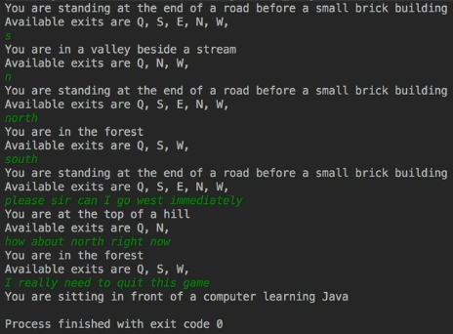

**Immutable Classes**  
* Immutable classes can’t be changed once they’re created.  
* The techniques are valuable if you want instances of your class to be immutable but also using some of the techniques in Immutable classes is a great way to increase encapsulation and to reduce errors even if you’re going to allow external code to modify your class instances.  
* It’s useful for example if third-party extensions or plugins are involved.  
* For those external developers, reading the API documentation will help them but it’s reasonable for them to assume that if they’re permitted to change fields and properties that they can go ahead and do so.  
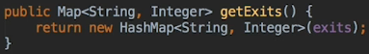  
* Our getExits method => rather than returning the exits object directly which would expose it to the potential for being changed externally, **we created a new HashMap object that contains all the elements of exits and return that** so external code that needs to use the exits, can do so, there’s no chance of changing our internal Map.  
* As it turns out, we could’ve in fact returned the list of available exits as a string which may be more convenient for our particular program but that would have reduced flexibility and that kind of approach is taken as a rule that we have to consider all the possible uses that external code may actually want.  
* Another technique is to **make our fields private and final**. That means that once they have been set, they can’t be changed.  
* You might argue that final was unnecessary here because if the fields are private, then they can’t be accessed externally anyway. While that’s true, the use of final does provide 2 benefits:  
1) makes it clear to anyone reading the code that the field shouldn’t be changed  
2) ensures that we don’t inadvertently change the fields if we change the code in the location class at some time in the future.  
* We didn’t provide setters for the locationID and description fields.  
* **It’s much better to only provide a setter if the class actually needs that**.  
* We’re discussing how to create an Immutable class so we’ll looking at a technique for settings the initial exits and then preventing further change.  
* **If a class field or elements of an Immutable class like a List or a Map is to be set only once and never change again, then it needs to be set in the constructor**.  
* Let’s now modify our constructor:  
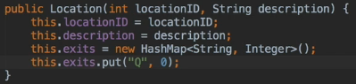  
* This way we don’t need the addExit() method anymore, we’re getting all the exits in constructor.  
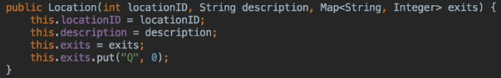  
* There’s one more change we need to make it truly immutable.

* ALSO let’s see how we can replace those easily without writing it manually:  
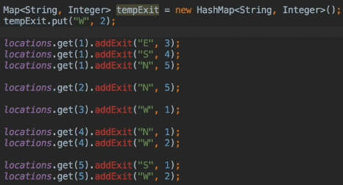  
* We can use the Find and Replace for the regular expressions.  
* Edit > Find > Replace… > Regex >   
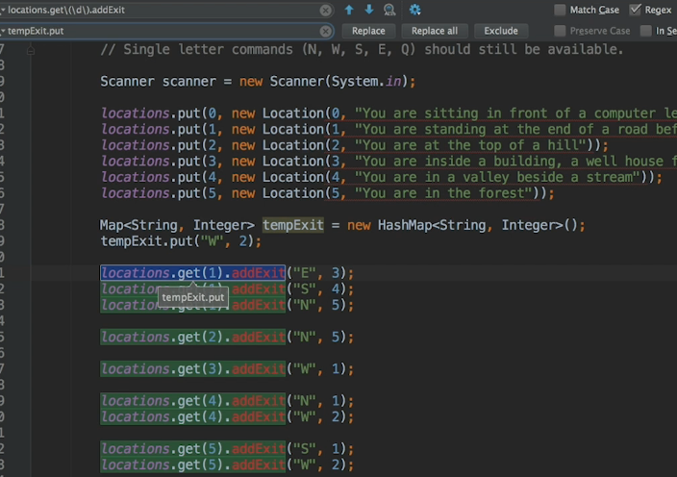  
* Click the IN SELECTION in the find options to affect only the selected area.  
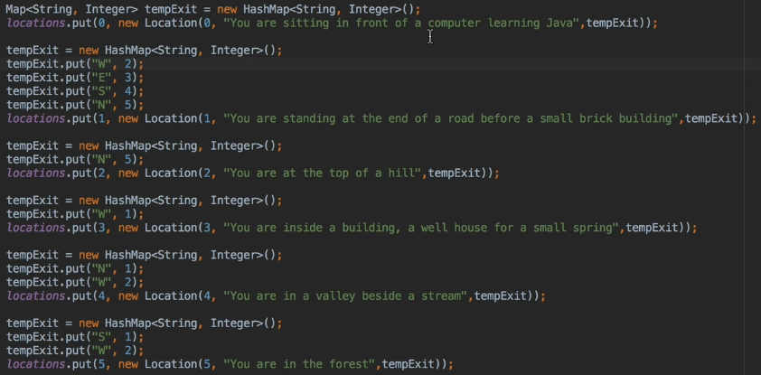  
* We still have 1 problem which exposes our class:  
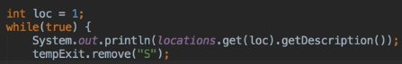  
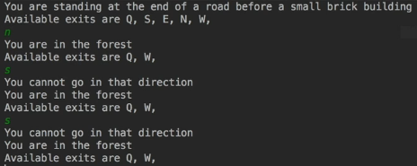  
=> We suddenly have no south because we managed to remove it. From the class that’s calling our Location class was able to delete part of the Map.  
* Let’s apply a similar technique we used for the getExits, this time for a setter:  
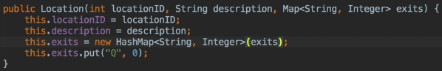  
=> **using new HashMap<String, Integer>(exits) instead of just exits**.  
* Now our class is fully immutable. Once an instance is created, it can’t be changed. This means that it could be used as a key to a Map with no ill effects for example.  
* Even though we won’t use it as a key, these techniques resulted in a very secure class that fully encapsaulates its fields. Depending on the functionality a class must provide, it may not be possible to employ all these techniques. They should certainly be considered and you should be doing that when you’re creating classes - considering these things, as many of them as possible used in order to increase encapsulationd and of course reduce errors as a result.  
* There’s 1 further step that Oracle recommends when creating fully immutable classes:  
=> **make the class final to prevent it from being subclassed**.

**Immutable Classes Challenge**  
* What exactly is wrong with allowing a class to be extended?  
* Our Map in Main:  
  
* It’s declared using generics so that it accepts and Integer key and a value of type Location, but if Location is extended, then instances of the new class could also be used so this is generally not a problem and in fact it’s actually incredibly useful, but if we use the Location type for the key instead of the value, and we wanted to ensure that only completely immutable objects could be used as the keys, then we’d have to prevent subclasses over which we have no control, from being used so anyone who wants to use functionality of the Locations class, once we prevent them from extending it, can still do so using composition. They create methods that then call the Location class methods from an instance of a Location. That could still do almost everything that subclassing would’ve allowed them to do except use their own class where Location object was expected.   
* **Most of the time you don’t want your classes to be Immutable. A bank account class where the balance never changes would be of little use. But even if you don’t want an immutable class, you can use these techniques in various combinations to make your classes certainly more robust than if you didn’t do anything at all**.  
* Challenge: there’s still a problem with Location. It’s possible to crash the program as a result. The problem is with the Location class itself. There’s also no consistency checking in the Main method so if we created exits that refer to a Location that doesn’t exist in our Locations map, then program will also crash. But let’s now deal with the Location class constructor problem.  
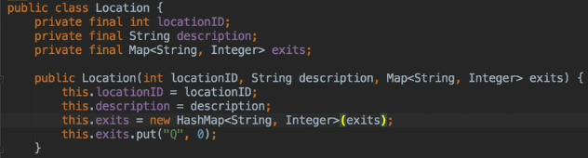  
* The problem would allow the program to compile but would crash at runtime.  
* The problem is that the constructor will crash with a NullPointerException at the new HashMap line if null is passed instead of the Map.  
* Example crash:  
  
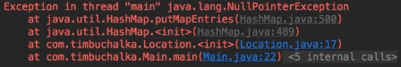  
* But it might make sense to pass null - let’s say it’s a special Location where there are no exits.  
* Solution:  
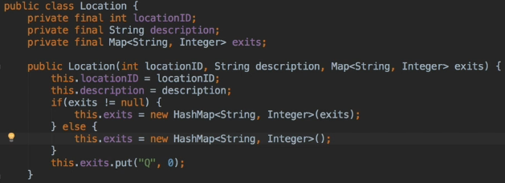

**Sets & HashSet**  
* Let’s talk about the Set interface and HashSet.  
* Sets are generally used less often than lists and maps but they can in themselves be extremely useful. Where a List is an ordered collection of items that can contain duplicates, a Set has no defined ordering and a Set can’t contain duplicates. The lack of duplicates is the most important differentiator as there are ordered sets such as the LinkedHashSet and TreeSet.  
* Set interface is GENERIC just like everything else in the Collections framework.  
* It takes a single type.  
* Like with Maps and Lists it’s possible to create a raw Set but this is intended really for backwards compatibility with code created before generics were added to the Java language and generally speaking it’s not a good idea to do that.  
* The Set interface defines the basic methods:   
**add()   
remove()   
clear()**   
to maintain the items in the Set  
**size()  
isEmpty()**  
to provide some information about how many items are in the Set.   
**contains()**  
to check if a specific item is in the Set  
* There’s no way to retrieve an item from a Set. You can check if something exists and you can iterate over all the elements in the Set but attempting to get for example the 10th element from a Set isn’t possible. You need to use a List to do something like that.  
* We’ve already used a Set when looking at Maps - the keys in the Map can be retrieved as Set using the **keySet()** method so it’s not surprising that **everything we said about keys in a Map also applies to items in a Set**.  
* Using immutable objects as elements in a Set can cause problems and the behavior’s undefined if changing an object affects equal comparisons.   
* **Just as a Map can’t contain itself as a key, a Set can’t be an element of itself**.  
* The best-performing implementation of a Set interface is the **HashSet** class and that uses hashes to store the items. This is just like a HashMap class that we looked at anad in fact the HashSet implementation currently uses a HashMap as of Java 8.  
* With the Set can be implemented using a Map, you could actually use the corresponding Map object and use only the keys, ignoring the values.  
* Whenever an element is added to the Set, it becomes a key in the underlying HashMap and a dummy object is stored as the value.  
* So Sets can be useful because operations on them are very fast and if you’re dealing with the mathematical notion of a Set, then the Java Collection Set types really allow the usual Set operation such as union and intersection which is pretty cool.  
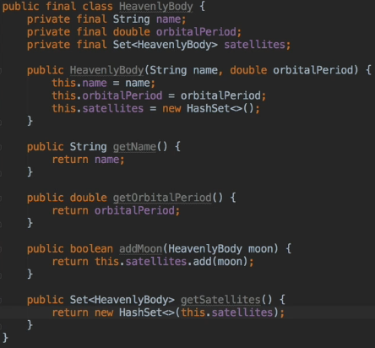  
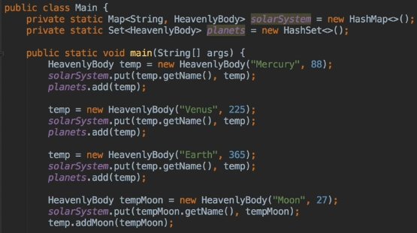  
* Let’s also copy and paste a few more planets/moons  
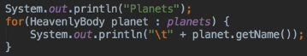  
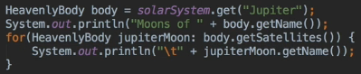  
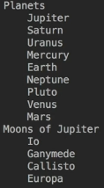

* We can easily create a list of all the moons by using union on Sets and thanks to the fact the are no duplicates, the result will be correct.  
**addAll()**  
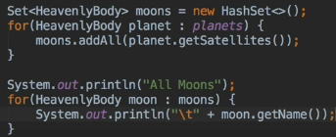  
* One thing that sometimes confuses people with code like this is that it’s only references to the objects that are being stored in the Sets. So Europa for examplea appears in the solarSystem Map and in the Set of satellites for Jupiter, but there’s really only one instance of the HeavenlyBody class for Europa so this confusion can lead to a common mistake when dealing with Collections where in our example the Sets would contain the names of the bodies rather than references. So code like that works but it’s the reasoning behind it that is incorrect.  
* So if the HeavenlyBody class contained kilobytes inffrmation on each body, the faulty reasoning is that it’s more efficient to just store the String name in the Sets or whatever Collection type you’re using for that matter.  
* But a reference to a String is exactly the asme size as a reference to any other object, so nothing is gained and the code becomes more complex because the actual object has to be retrieved from that Map before you can get any of its details so that’s really an important consideration.  
* If the ID of the object was an integer rather than a string, then it might be tempting to store that in the Sets but this is also a false optimization - so on a 32-bit Java Virtual Machine an int and an object reference both take 4 bytes and 4 bytes = 32 bits. On a 64-bit JVM the object reference would normally be 8 bytes = 64 bits. But interestingly enough, Java 7 uses compressed pointers that can even end up using less space than the 32-bit int.  
* Having said all that, there’s 1 good reason for using the body’s name in the Sets and that’s got nothing to do with using memory more efficiently. In previous sections we discussed making classes immutable and the reason we’re doing that is so they can be used as the keys in a Map and a Set of course has the same restrictions and warnings as Map keys. Unfortunately though our HeavenlyBody code can’t be made immutable because new information is constantly being discovered about planets even in our solar system.  
* We’ve allowed moons to be added to planets which is what makes our HeavenlyBody class mutable, but that’s necessary.  
* Java doesn’t prohibit using immutable objects and sets in its Map keys but there are some recommendations that should be followed and we’ll look at those in the next video.

**HashSet - equals() and hashCode()**  
* **Java documentation does warn you that if you’re using your own objects as either a key in a Map or as an element in the Set, you should override the equals() and hashCode() methods**.  
* If we now store Pluto again but with a different number, it will get stored in the Set.  
* The reason is the 2 Java objects do not compare equal so the Set is happy to accept both of them for that reason. And if we use them as keys in a Map, same thing will happen as well.  
* This is why the equals() method has to be overwritten in our HeavenlyBody class.  
* The reason they don’t compare equal is because the base object class from which all other classes are derived, just defines a very simple equals() method that performs what is know as **referential equality** and it means if both references point to the same object then they’re equal, otherwise not.  
* It basically uses == to perform a comparison. The same issue would be with == used on strings.

* This is the .equals() overridden method that’s part of the String.  
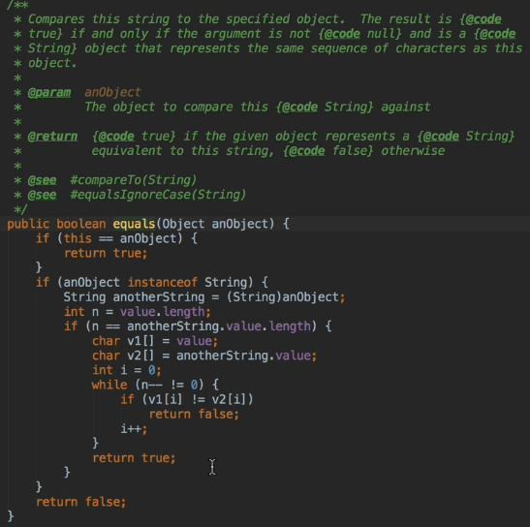  
* In our example when we’re dealing witho our own class, we really need to be careful here because thinking about it if our HeavenlyBody class is subclassed, instance of it will return true when an object of the subclass type is used here so we need to look at an alternative check to perform when we implement equals() for our HeavenlyBody class.  
* **Unfortunately, overriding equals() is not really that straightforward - if 2 objects compare equal, then their hash codes must also be the same which is why you must override the hashCode() method**.  
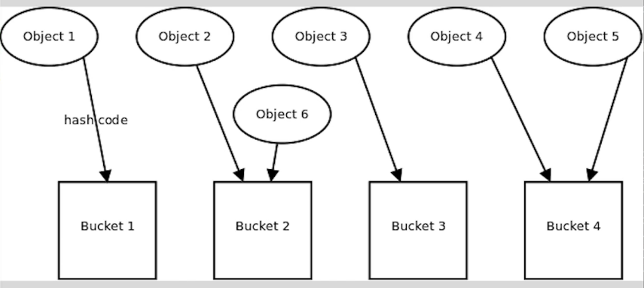  
* When storing objects in a hashed Collection such as HashSet or HashMap, think of the collection as having a number of buckets to store the objects in.  
* The HASH CODE determines which bucket our objects are gonna go into.  
* There’s a requirement that any objects that are equal, should always have the same HASH CODE and ultimately so that they’ll end up in the same bucket. But the opposite is not required so 2 objects that aren’t equal don’t have to have different hash codes in the diagram.  
* There may already be objects in that bucket so each is compared to the new object to make sure that it’s not already in there. Now because the comparison is performed using the equals() method, the Collection will only know if it’s already there if it’s looking in the right bucket so the HASH CODES must be the same and equals() returns true. It’s no use for equals() returning true if the Collection is checking the wrong bucket. That is if the HASH CODE for the new object is not the same as an object that its equal to.  
* If the new object breaks the rules and has a different HASH CODE, even though it compares equal() to it, then the Collection will be looking in the wrong bucket and ultimately won’t find it so we would get a duplicate.  
* But it can get even worse than that - if we then iterate over the Collection trying to find that new object so that we can remove it, we may get to the old object first and not the new one so our code will check if the object we’ve just pulled from the Collection is the same as the one we wanna remove and of course equals() will return true so we remove the old object from the collection but actualy remove the original, not the duplicate.  
* So ultimately **there has to be a strict relationship between equals() and hashCode()**.  
* For HeavenlyBody we just need to check the name to find if they’re equal.  
* **It’s very common and easy mistake to overload the equals() method rather than overriding it**.  
* **You can see an error underlining the @Override, that’s a useful indication**.  
=> The obj types are different!  
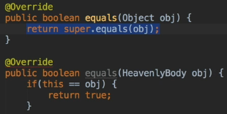  
* So we can change that in our definition too:  
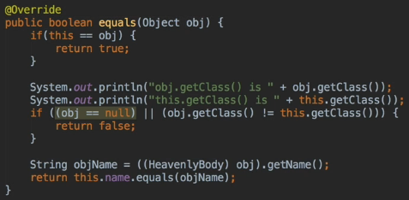

**Finish off equals() and hashcode()**  
* In terms of the implementation for the hashCode() it actually appears extremely easy because the String class has a hashCode() method and because we’re comparing only Strings because we decided in the equals() method that our comparison is going to be just the name of the HeavenlyBody.  
* So you’d think that we could just generate the HASH CODE for the body’s name:  
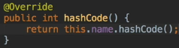  
* This would actually work here because we’ve typed the Sets and the Map using GENERICS so there’s little danger of comparing let’s say a HeavenlyBody to a String but it’s not really a good practice though to do this because a HeavenlyBody called Pluto would probably have a different HASH CODE than the String Pluto.

* How you generate HASH CODES is pretty much up to you as long as the same object will always generate the same HASH CODE during any execution of your program and also as long as objects that compare equal have the same HASH CODE. Once that’s done then the requirement is satisfied.  
* If you search for overriding HASH CODES on the Internet, you’ll find some recommendations that you can just return 0. Every instance of your object will then have the same HASH CODE which certainly meets the requirement that two objects that compare equal have the same HASH CODE and also means that no matter how many times you generate a HASH CODE for an object, it would always be the same in that scenario.  
* But if you think about it, it sort of misses the purpose of hashing in the first place. If every object of a Hashed Collection ends up in the same bucket, then you totally lose the performance benefits of using Hashed Collection class. The performance in that case will drop to that of a LinkedList or a similar structure and that’s because once the single bucket has been located which is bucket 0, the items will each need to be compared to see if the required one is in there. So it’s very much less efficient doing it that way.  
* **Adding a number to the name’s HASH CODE will make it different and that’s what we’ll do here**.  
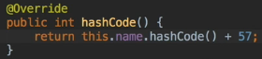  
* This then guarantees that we’ve got a non-zero number that’s been returned for each of our hashes. We’re using the code that comes back from a String but we’re adding 57 to that as well so it’s a non-zero number because HASH CODE from the String source code is returning its own HASH CODE and we’re adding the number 57.  
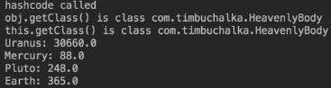  
* Pluto is now only 1 in the Set.  
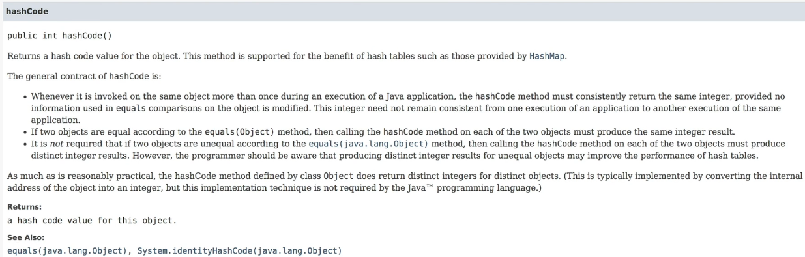  
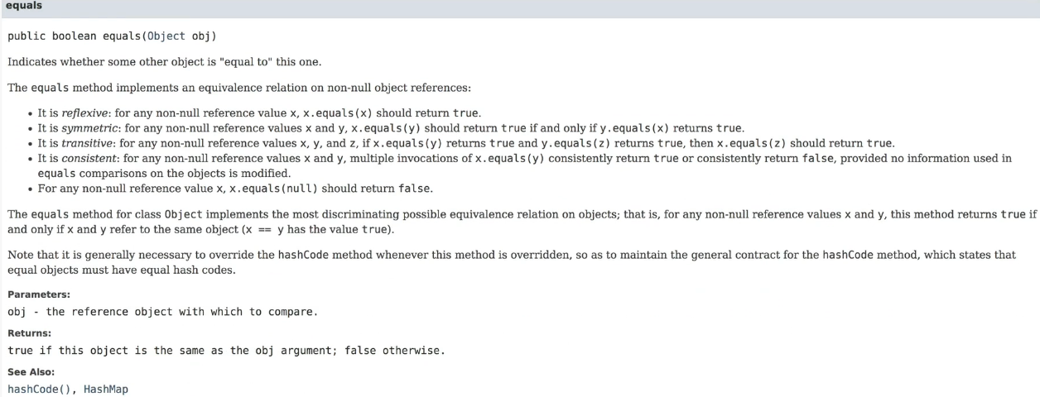

**Potential issue with equals() and sub-classing**  
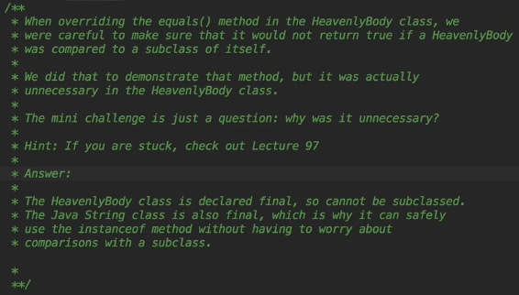  
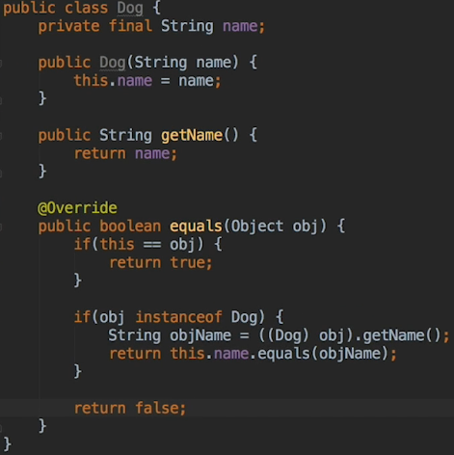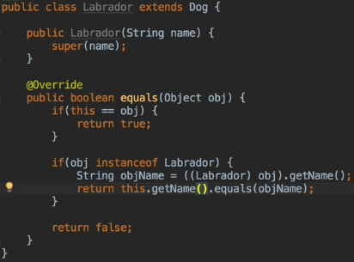  
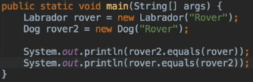  
  
* Labrador is an instance of Dog but Dog is not an instance of Labrador.  
* **This violates that symmetric rule that the equals() method must obey, basically has to be equal on both sides of the coin**.  
* **The best way to fix this is to not override the equals() method in Labrador so we can remove it**.  
* **To make sure that equals() can’t be overridden in subclasses of Dog, what we want to do is mark it as final**.  
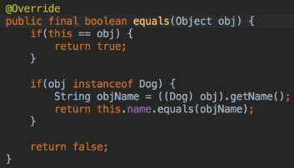  
* This really shows that a great deal of thought is needed when you’re overriding equals() and of course therefore hashCode(). If you want your classes to be subclassed, you need to think about how you treat comparisons between the subclass and its base class.  
* If a subclass is likely to be a different object, then use the method we used in HeavenlyBody to make comparisons between the subclass and its base class return false. So if needed these would really fit then prevent subclassing and force clients to use composition instead.  
* So we’ve now seen how to implement an immutable class that can be safely used as either a key in a Map or as an element in a Set.  
* The HeavenlyBody class isn’t immutable because we can add moons to it but any change we make to it won’t affect either behavior of equals() or the hashCode().

**Sets - Symmetric & Asymmetric**  
* We’re going to finish our discussion on Sets and we’re gonna start by looking at the remaining mathematical operations that are usually performed on them.  
* We’ve already seen **addAll()** to create the UNION of two Sets.  
* It’s one of what the Oracle documentation calls “bulk” operations that can be performed on Sets.  
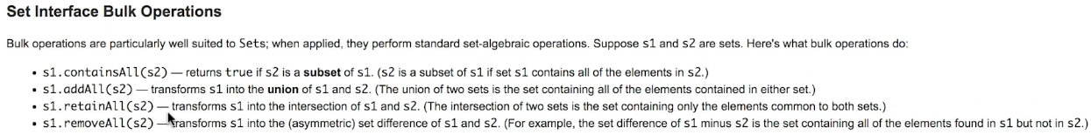  
* We’re going to look at how to perform set intersection and difference as well as checkinf if one set is a super set of another or whether the second set is a subset of the first which effectively amounts to the same thing.  
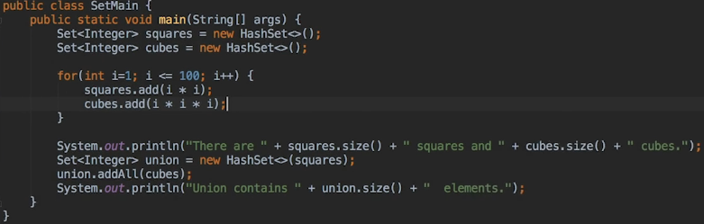  
* Because these bulk operations are destructive = they modify the set that they’re called upon, the program that we typed in created a new set containing the member of squares and cubes.   
* We created a new union variable because the bulk operations are desctructive.   
* So by creating a new HashSet we’re able to make sure that we’re not affecting any existing sets that we’ve previously created.  
* So we use that initially to create a new HashSet, passing squares to the constructor for the Hashset which added those entries and then using the .addAll() to add in the entries from cubes as well.  
* **retainAll()** => **intersection**.  
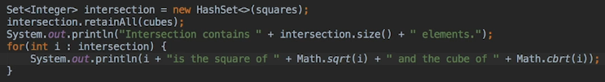  
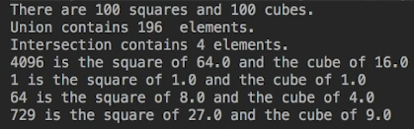  
* **removeAll()** => **removes all elements in one set from another**.

* **Collections Interface suggests that all classes that implement Collection should provide 2 standarad constructors. 1st one should take no arguments to create an empty collection but the 2nd one takes a Collection argument to initialize new collection with all the items in the collection that is passed to the constructor**.  
* This is only a suggestion because interfaces have no constructors so this behavior can’t be enforced.

* The Array class also provides **Arrays.asList()** method that’s used to return a List view of the elements in the Array, in fact it actually uses an ArrayList.  
* **This method provides a convenient way to initialize a collection with a List of values as there’s still no Set or Map Literals in Java**.  
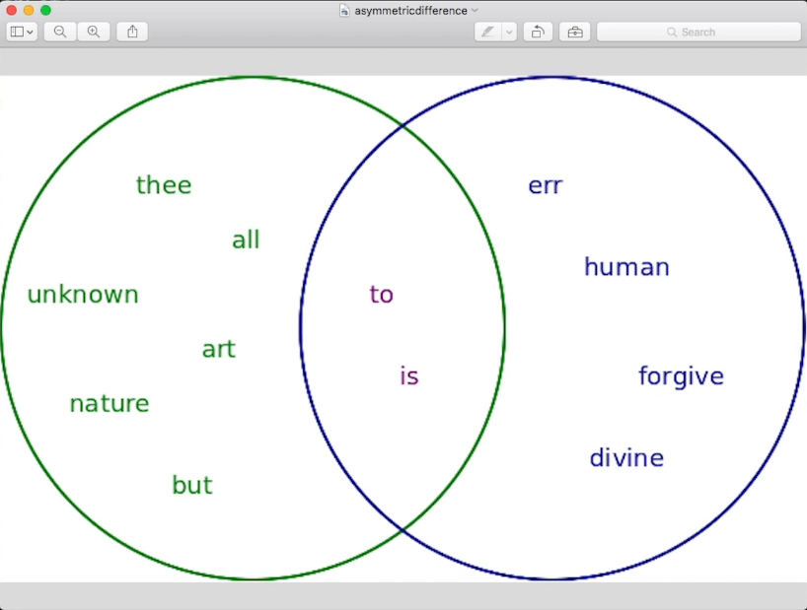  
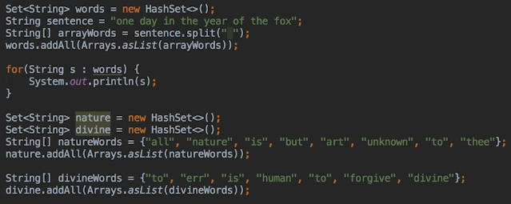

**Finishing Off Sets**  
* **removeAll()** => **Asymmetric difference**.  
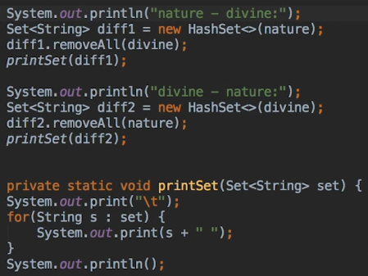 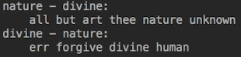

* Java doesn’t have a method for calculating the symmetric difference possibly because that’s used less often when dealing with sets. Now the symmetric difference as opposed to the asymmetric is the elements that appear in one set or the other but not both so it can therefore be defined as the union minus the intersection.  
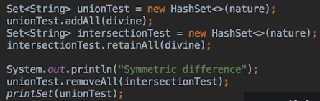  
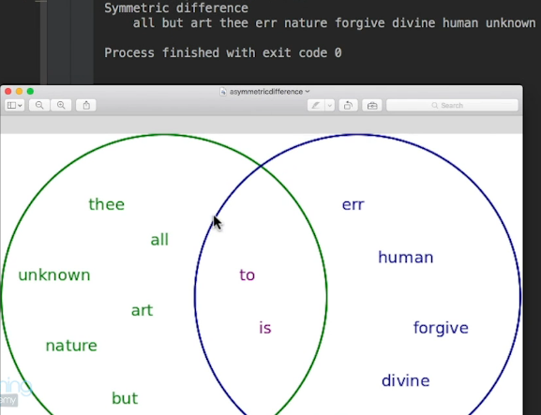  
* We should have all the green and blue.  
* **containsAll()** => **test if one set is a super set of another**. **This one’s non-destructive**.  
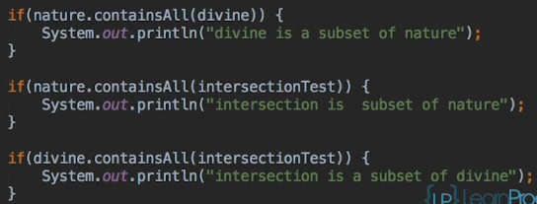  
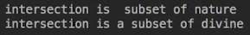  
* **Set can be a very quick way to get all the unique items in the collection**.  
* **Another thing to keep in mind is that the HashSet class itself is also very fast so they can be a really good way to group related items together even if you don’t plan to perform mathematical set operations on it**.

**Sets Challenge Part 1**  
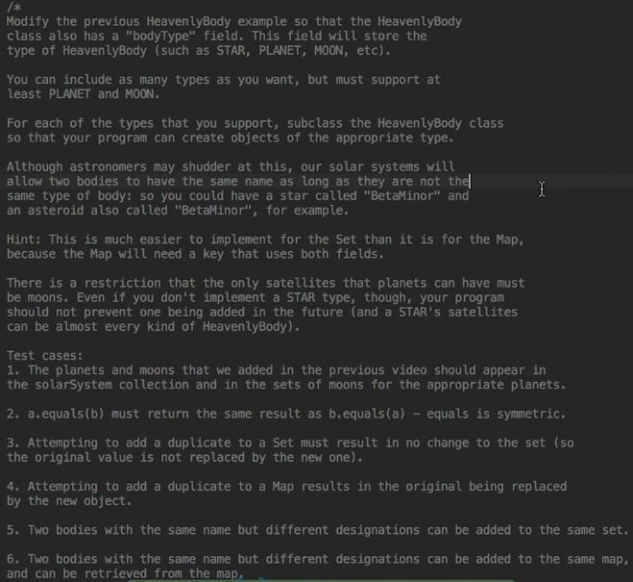  
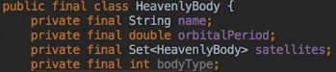  
* One way of defining the body types would be:  
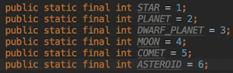  
* But let’s see a more convenient way using **enum**:  
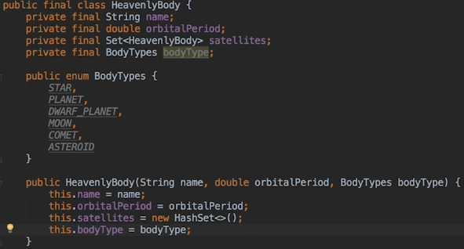  
* One advantage of using enum here is that enums are types and it means that when we change the constructor, we can make sure that it only accepts a valid bodyType.

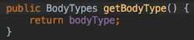  
* **The advantage of enum is that we get an error at compile time if bodyType isn’t valid**.  
* **A nested enum is automatically static so it’s possible to refer to the enum values without creating an instance of a HeavenlyBody object**.  
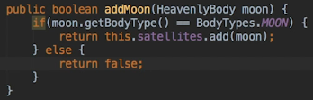  
* Doing this isn’t a good idea and thinking about it further the name itself of the method is badly chosen, HeavenlyBodies other than planets can have satellites and they don’t have to be moons. Most of the objects in our solar system orbit the Sun so if we restrict our moon like this, it makes it impossible to give a star satellites so we’re going to put this back to how it was and also refactor it to addSatellite which better reflects what is happening.  
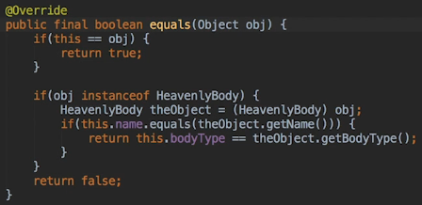  
* And if we want to restrict planets to only have moons orbiting them, we can override the addSatellite() method in the Planet class which I think is a much better design.  
* **To avoid problems with equals() not being symmetric, we’re going to mark the method as final**.  
* If equals() is final, then hashCode() should be final as well.  
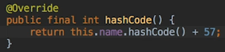  
* enums constants have a hashCode() method as well.  
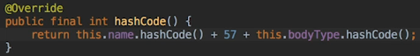  
* The next method that I want to add is optional but it makes printing out the HeavenlyBodies easier.  
* We’re going to override the toString() method so that it displays the bodyType and orbital period as well as the name.  
* **Another advantage of enums is when you print them out, in this case we’re going to print the toString method that comes with the enum returns the name of the enum in other words we’ll get whatever the names that we defined**.  
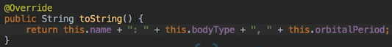  
* **When we use an object in a string concatenation like this, Java implicitly calls toString() method to obtain a string representation of the object**.  
* We need to remove the `final` from our HeavenlyBody class so that it can be subclassed.  


**Sets Challenge Part 2**  
* Since only moons can be satellites for a planet, it makes sense to do this check here.  
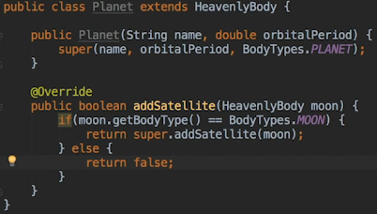  
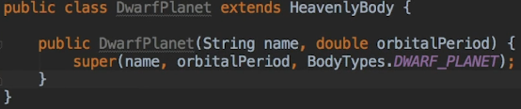  
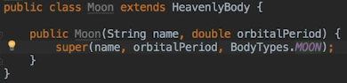  
* In our previous main method let’s fix the HeavenlyBodies to be the right class:  
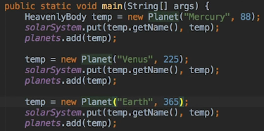  
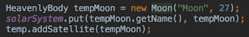  
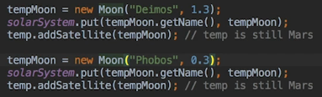  
* If we do something like this, it’s certainly valid as well:  
  
* We can also change the way we print them as well, to use our toString() method:  
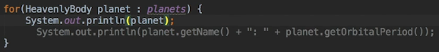  
* That’s gonna invoke the toString() method.

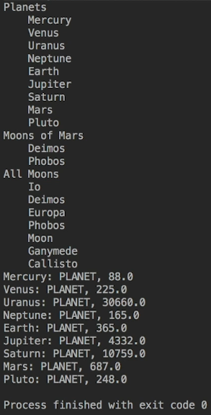  
* You can see that Pluto is not there twice anymore.  
* The second Pluto has not overwritten the original Pluto which is what we want.  
* **Even though it could make sense to allow HeavenlyBody objects to be created, it’s probably better to make HeavenlyBody abstract**.   
  
* One problem is that our second Pluto can have planets added to its set of satellites. In fact it could even have the Sun as a satellite which can lead to a very strange solar system.  
  
* Now Pluto appears twice because it’s a different type.  
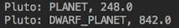  
* Now let’s make sure our equals() is symmetric:  
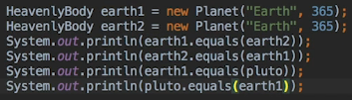 true, true, false, fase

**Sets Challenge Part 3**  
* There’s a potential Map issue and the issue is with the solar system:  
  
* Because if we have a look and see how that’s actually defined, what we’re doing is defining it purely with the name of the body (a String) and there’s currently no way to cater for the bodyType. And obviously because we’re using a map, we only got the concept of a key and the values so how do we get around that?  
* Well it’s actually very commom problem when attempting to store and retrieve more complex objects whether using one of the Collection classes or a database for that matter.

* There are many solutions to this problem - databases allow records to be selected on several fields so it is possible to make a primary key that consists of all the fields that uniquely define each record.  
* Another approach is creating unique serial numbers for each record such as a social security number for people in the US. National Insurance numbers in the UK and text phone numbers in Australia. One drawback of this approach is that you can’t retrieve someone’s record from a Map unless you actually know their serial number.  
* Interestingly enough, objects that have been discovered in the universe are given a serial number by the International Astronomical Union.  
* So if you want to add an IAU number field to the class and use that, that’s perfectly valid solution. You’d change referencing the name and refer instead to the IAU field.  
* You may have also concatenated the name and bodyType to create strings such as PLANET and DWARF_PLANET. That would also be fine because that’s covering both the name and also the bodyType as well.  
* **But for my solution I’mm gonna create a key class and give the HeavenlyBody class a field of type key. Because this key is gonna be closely tied to the HeavenlyBody class, I’m gonna make it a static inner class of the HeavenlyBody class**.  
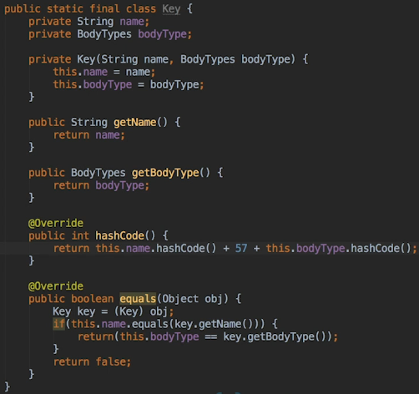  
* As you can see, the Key class is very simple and g ives a way to deal with a combination of name and bodyType in a single object.   
* Now because we’re gonna be using the key in a Map, that’s why we needed to override equals() and hashCode() methods.  
* Generally speaking it’s a bad idea to have duplicated code like this, but we can fix that by making HeavenlyBody methods just call the methods in our new Key class and the equals() method still needs to check that the object being compared is a HeavenlyBody and must cast to a HeavenlyBody bodyType in order to access its key.

* Changing this:  
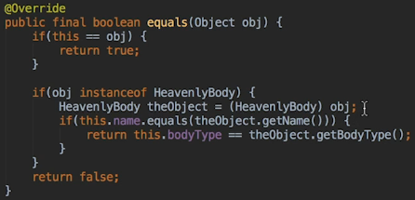 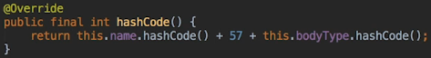  
* To this:  
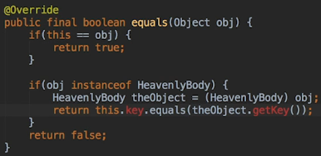 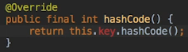  
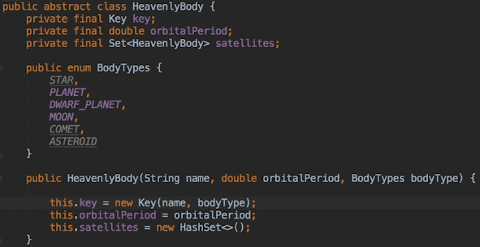  
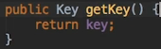  
* Now even t hough we’ve defined the Key inner class as a private constructor, that works because this is an inner class to our HeavenlyBody.  
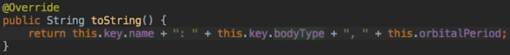  
* The method we have to make is to make a key so the actual implementation of the key is not something that users of the class should know about, but in order to retrieve a HeavenlyBody from the Map, we need a key when all we really had until now is a name and a bodyType.  
* **What we want to do is pass a name and the bodyType and have the method return the valid key which is gonna be then used to look up that entry in our Map**.  
* Let’s create it static so that the key can be obtained without an instance of HeavenlyBody to call the method on.   
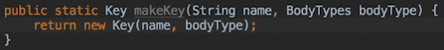

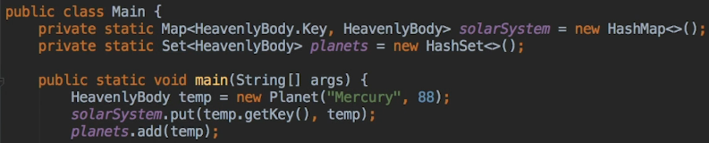  
* We change the type in solarSystem Map and we use the getKey() method as the key when adding.  
* The other thing is because we’re referencing key, we haven’t added a toString() method to that:  
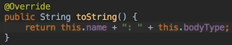  
* We need a toString() method in the Key class, not only the HeavenlyBody class.  
* This won’t work anymore:  
  
  
* Also in the Planet class:  
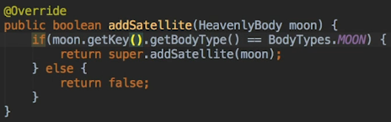  
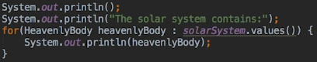

**Sorted Collections**  
* So far we’ve looked at:  
=> **List interface** => **ArrayList** and **LinkedList**  
=> **Map** **interface** => **HashMap**  
=> **Set interface** => **HashSet**   
* There’s 2 other Collection interfaces: **Queue** and **Dequeue**, we’ll look at those later in the course.  
* Now let’s look at the variant of the HashMap and HashSet classes, which is called:   
=> **LinkedHashMap** and **LinkedHashSet**  
* There are also sorted versions of the Map and Set interface:   
=> **SortedMap** **interface** => **TreeMap**   
=> **SortedSet** **interface** => **TreeSet**  
* Because the operations on Maps and Sets are so similar, the examples in here will concentrate on the Maps rather than Sets.  
* The Linked variants of HashMap and HashSet are called LinkedHashMap and LinkedHashSet and any real difference is that they got an ordering to them. They maintain insertion order.

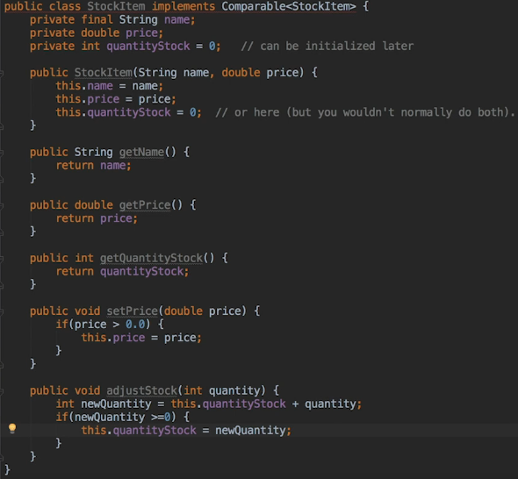  
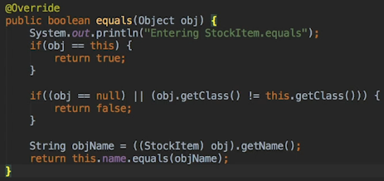  
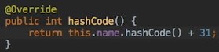  
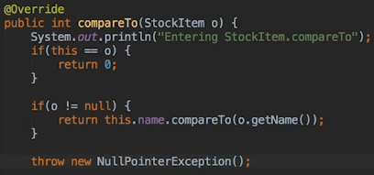  
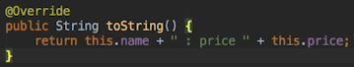

* Let’s now overload the constructor to allow to set the quantityStock as well if we want.  
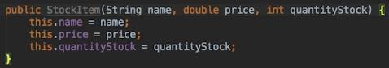

**StockList Class With Maps**  
* **getOrDefault()** => it will get the item if it already exists, else it’s going to use the default item:  
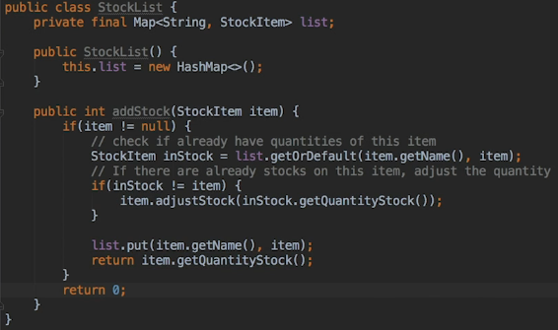  
* A different way of doing it would be:  
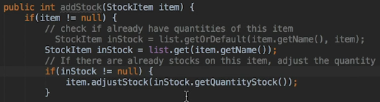  
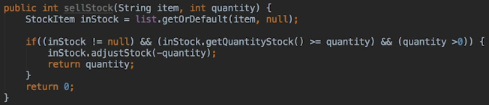  
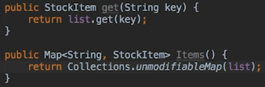  
* **Collections.unmodifiableMap()** => a Map that can’t be modified.  
* **Map.Entry<type, type>**  
* **entrySet()**  
* **getValue()**  
* Let’s also rename the getQuantityStock to quantityInStock which makes more sense here.

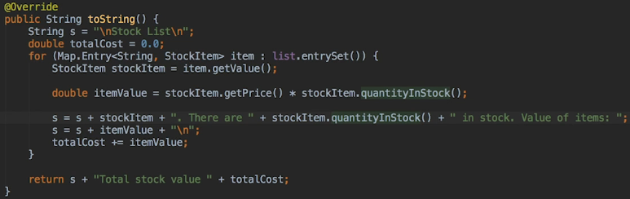  
* This is pretty cool but generally it’s probably not a good idea to do this in practice because toString() is really intended for debugging.  
* Now the program using the StockList will probably want to display the list in different ways and so the StockList class also has an Items() method that provides a Map of all items in stock.  
* **The Collections framework provides a wrapper around the List, Map and Set collection to provide an unmodifiable collection**:  
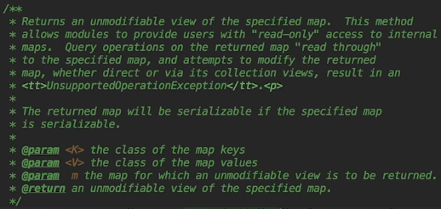  
* **So what we are really returning is a read-only view into our Map and this prevents other code from adding or removing items and it’s faster than the previous way from lecture 107 and the reason it’s faster is because it doesn’t have to make a copy of the collection**.

**Add a Basket**  
* We used a Map for the StockList and the reason I did that was because this section is about the Java Collections Framework but the actual StockList could be stored in a number of different ways and with the database probably being the most likely one that you go for.  
* I could have just used the name as the key instead of the item but then the Basket class would have to look up the items in the StockList to update the stock count or get the price. So by storing the actual items, the Basket class can retrieve any information that it needs directly from the item which obviously is pretty convenient.  
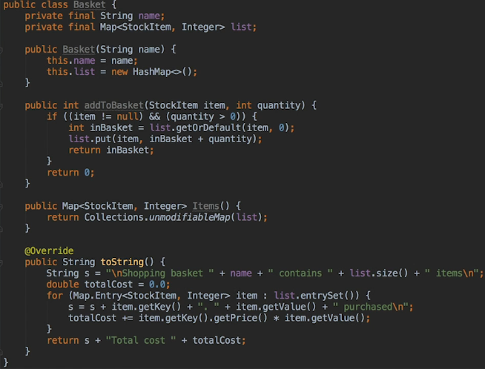  
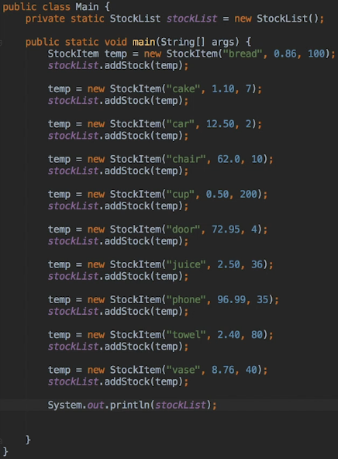  
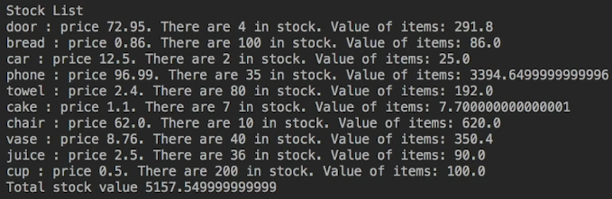

* Let’s fix the outputs so it doesn’t show so many decimal numbers, change:  
  
* to:  
  
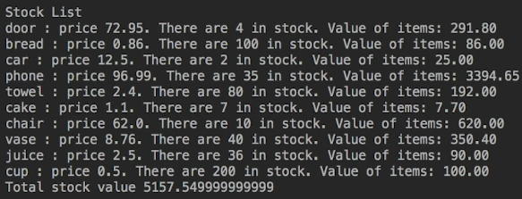  
* The items are still stored in a random order. The reason is because the StockList class is using a HashMap to store the items, the orderings are undefined for that reason.  
* To maintain the alphabetical order, we’re gonna change StockList to use the LinkedHashMap instead.  
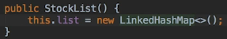  
* Now it is in an alphabetical order - the order we passed it in.  
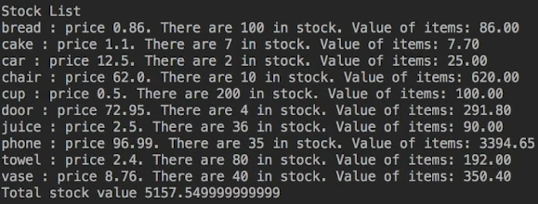  
* That’s one of the advantages of using generic set ups by using Map interface, it was super easy to change it from HashMap to LinkedHashMap on one line.  
* This in Main also prints them out in an alphabetical order:  
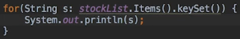

**TreeMap and Unmodifiable Maps**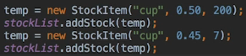  
  
* Let’s now create a method in Main for selling some.  
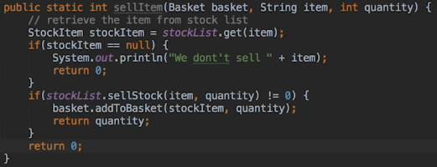

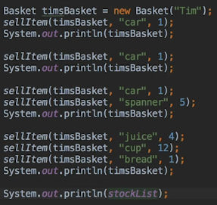  
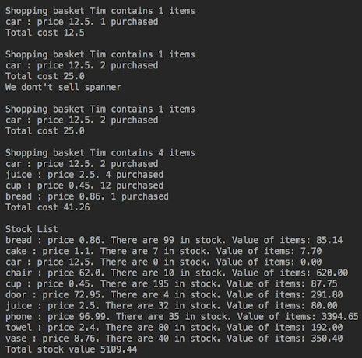  
* Let’s adjust our toString() method to print item/s based on the size:  
  
* The Basket items appear in random order.  
* We could change the Basket’s HashMap to LinkedHashMap, but this is a good opportunity to see a **TreeMap** in use.  
* Because we already implemented the Comparable interface in Basket, the only change we really need to make is to the constructor itself to get this to work.  
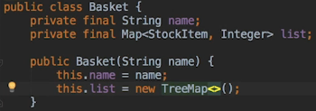  
* Now it’s in an alphabetical order and notice that compareTo() is now being called, and that’s because we’re using a TreeMap and it’s sorting it for us automatically.  
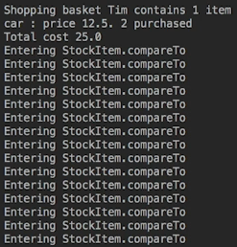  
* The point is that adding items to a TreeMap results in far more work for your code than using a HashMap, and that’s because each time we’re entering a StockItem, it’s using the compareTo() method to check the order, comparing it.  
* **Now the reason for that is that because TreeMap has to actually check through its list to find the correct place to insert the new item, and of course it does it by comparing the items it finds with the item being added**.  
* **Now although the TreeMap implementation is quite efficient, keep in mind that there is a performance cost to having the items ordered and that’s something to consider when trying to decide between a TreeMap and one of the unsorted Map classes like HashMap and LinkedHashMap**.  
* Let’s try to use the StockList class items() method to bypass the correct way to add stock.  
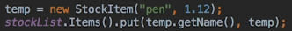  
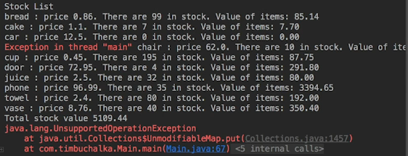  
* It’s an unmodifiableMap.  
* So you can see that’s a good security mechanism in place to ensure that there’s no other way that items can be added to our Basket other than using the methods that we’ve actually defined.  
* There’s 1 thing to be aware of when allowing calling code to access your collections. And this is even if you’ve only provided an unmodifiable object. Although the collection itself can’t be changed, which means that items can’t be added/removed, it’s only the collection itself that is unmodifiable. The individual objects in the collection can be accessed and modified.  
  
  
* If we do something like this:  
  
* There’s no problem in this case because we had the functionality available to do that anyway. So in this particular case there’s no problem with having access to the objects via the read-only collection.  
* **But if you design a system so that the StockList didn’t have a get() method, then you wouldn’t want the code to use the get() method on the unmodifiable collection either**.  
* So remember that **it’s the collection itself that is unmodifiable, and not the objects within it**.  
* By providing the items() method, the StockList class allows callers to retrieve individual items, and if you don’t want this to happen, then consider another way to provide a list of items, if indeed you provide that list at all.  
* So again if you design a system so that the StockList didn’t have a get() method, then you wouldn’t want code using the get() method of the unmodifiable collection either.  
* Let’s see one possible option:  
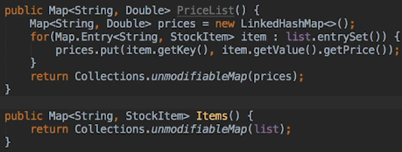  
* Now in Main:  
  
* So here, we’re providing an unmodifiableMap of names and prices for the caller to use. The entries in the Map consist of pairs of **Strings** and **Double** --- **both of these are immutable**. So not only can’t the Map be modified, but the individual entries in it can’t be either.  
* **So if it’s important that access to your objects in your collection is restricted, then avoid returning any sort of collection that contains the actual objects**.

**Challenge Part 1**  
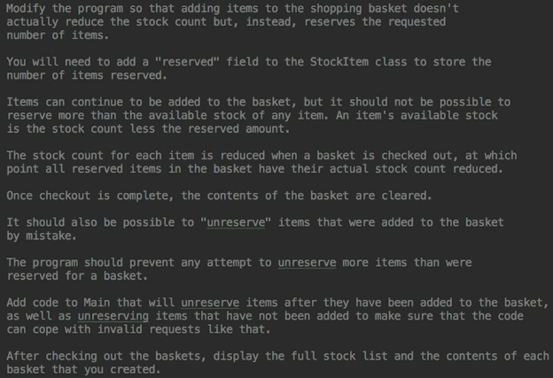

* **In StockItem**:  
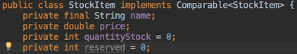  
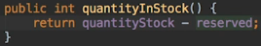  
* At the moment the only way to manipulate stock levels is to use the adjustStock() method which allows negative and positive quantities to be used, it just makes sure that the quantity isn’t negative after the adjustment.  
* We’re not gonna touch adjustStock() for now.  
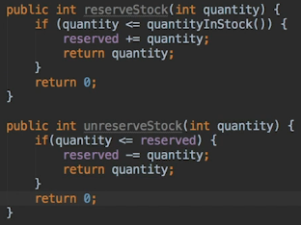  
* Let’s have a look at the quantityInStock FIELD and quantityInStock() METHOD. In Java, it’s legal to have a field and a method with the same name. So this code actually works fine.  
  
  
* Using the same name was acceptable when the new method was just returning the value of the field it was named after. But now it’s performing an extra step (using the reserved value), so we should really give it a different name.  
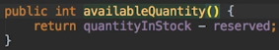  
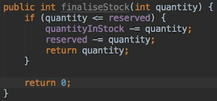  
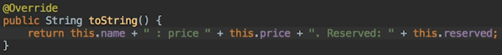

**Challenge Part 2**  
* **In StockList** we also need methods to reserve and unreserve stock.  
* These are the methods we have right now:  
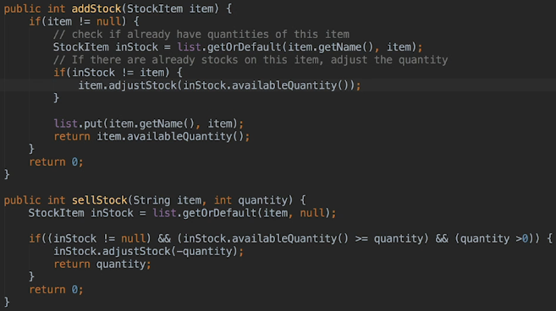  
* Let’s now create new methods:  
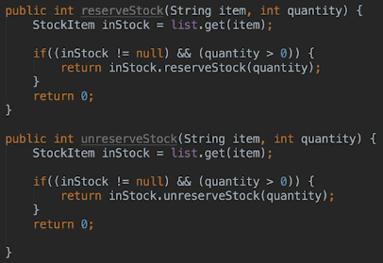  
* Now let’s change the sellStock() method:  
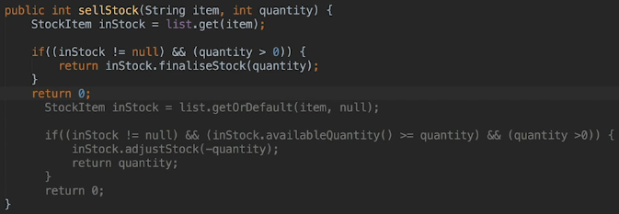  
* All checks for sufficient stock levels are performed in finaliseStock().  
* Now we need to provide the Basket class with a way to remove items from the basket.  
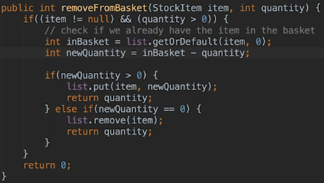  
* It is appropriate to use getOrDefault() here because if it is already in the Basket, we want to return the current quantity for this item, otherwise we want to return 0.

**Challenge Part 3**  
* **clear()** => of the Map object, it’s much faster than removing items one by one.  
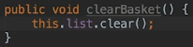  
* Let’s change the sellItem() method in Main.java and add the removeItem() method:  
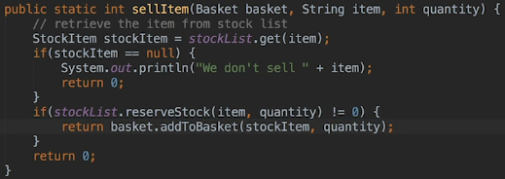  
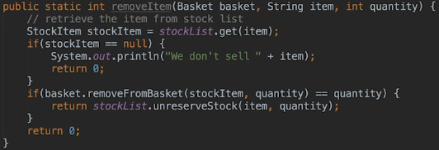  
* Let’s create a checkOut() method:  
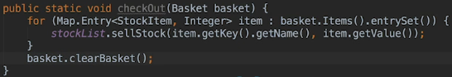  
* Now remove the print in the compareTo() method in StockItem not to clutter our displays:

**Challenge Part 4 (Final)**  
* Let’s do some testing now:  
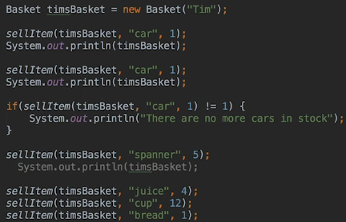  
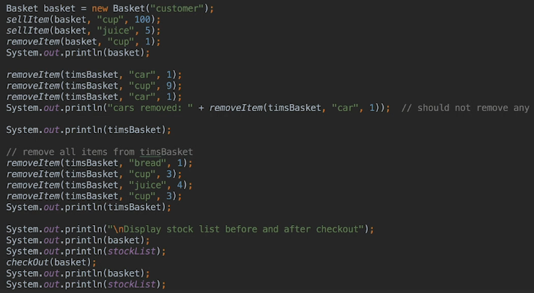  
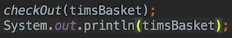

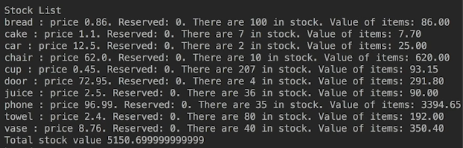

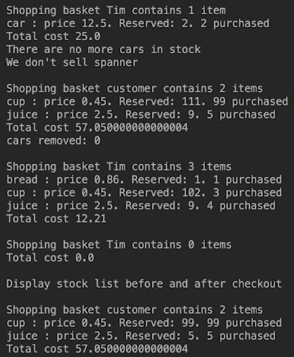

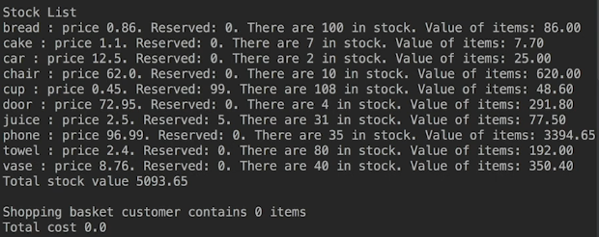  
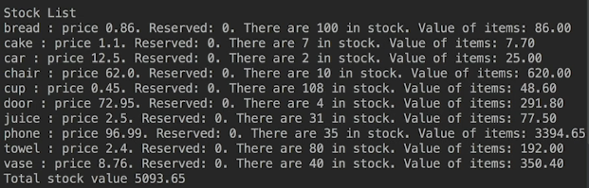  
* All this main functionality is working.  
* Now let’s check some of the boundary condition.  
* This would throw an error because we don’t check for a correct value:  
  
(if we comment out all the adding to stock so that there’s nothing in stock)  
  
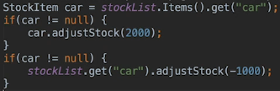

**Resources**  
Interfaces Java Docs  
<https://docs.oracle.com/javase/tutorial/collections/interfaces/index.html>  
Maps Document Link  
<https://docs.oracle.com/javase/tutorial/collections/interfaces/index.html>  
A Strategy for Defining Immutable Objects  
<https://docs.oracle.com/javase/tutorial/essential/concurrency/imstrat.html>  
Virtual Machine Performance Enhancements  
<https://docs.oracle.com/javase/8/docs/technotes/guides/vm/performance-enhancements-7.html>  
Equals documentation  
<https://docs.oracle.com/javase/8/docs/api/java/lang/Object.html#equals-java.lang.Object->  
The Set Interface  
<https://docs.oracle.com/javase/tutorial/collections/interfaces/set.html>  
International Astronomical Union (IAU)  
<https://en.wikipedia.org/wiki/International_Astronomical_Union>